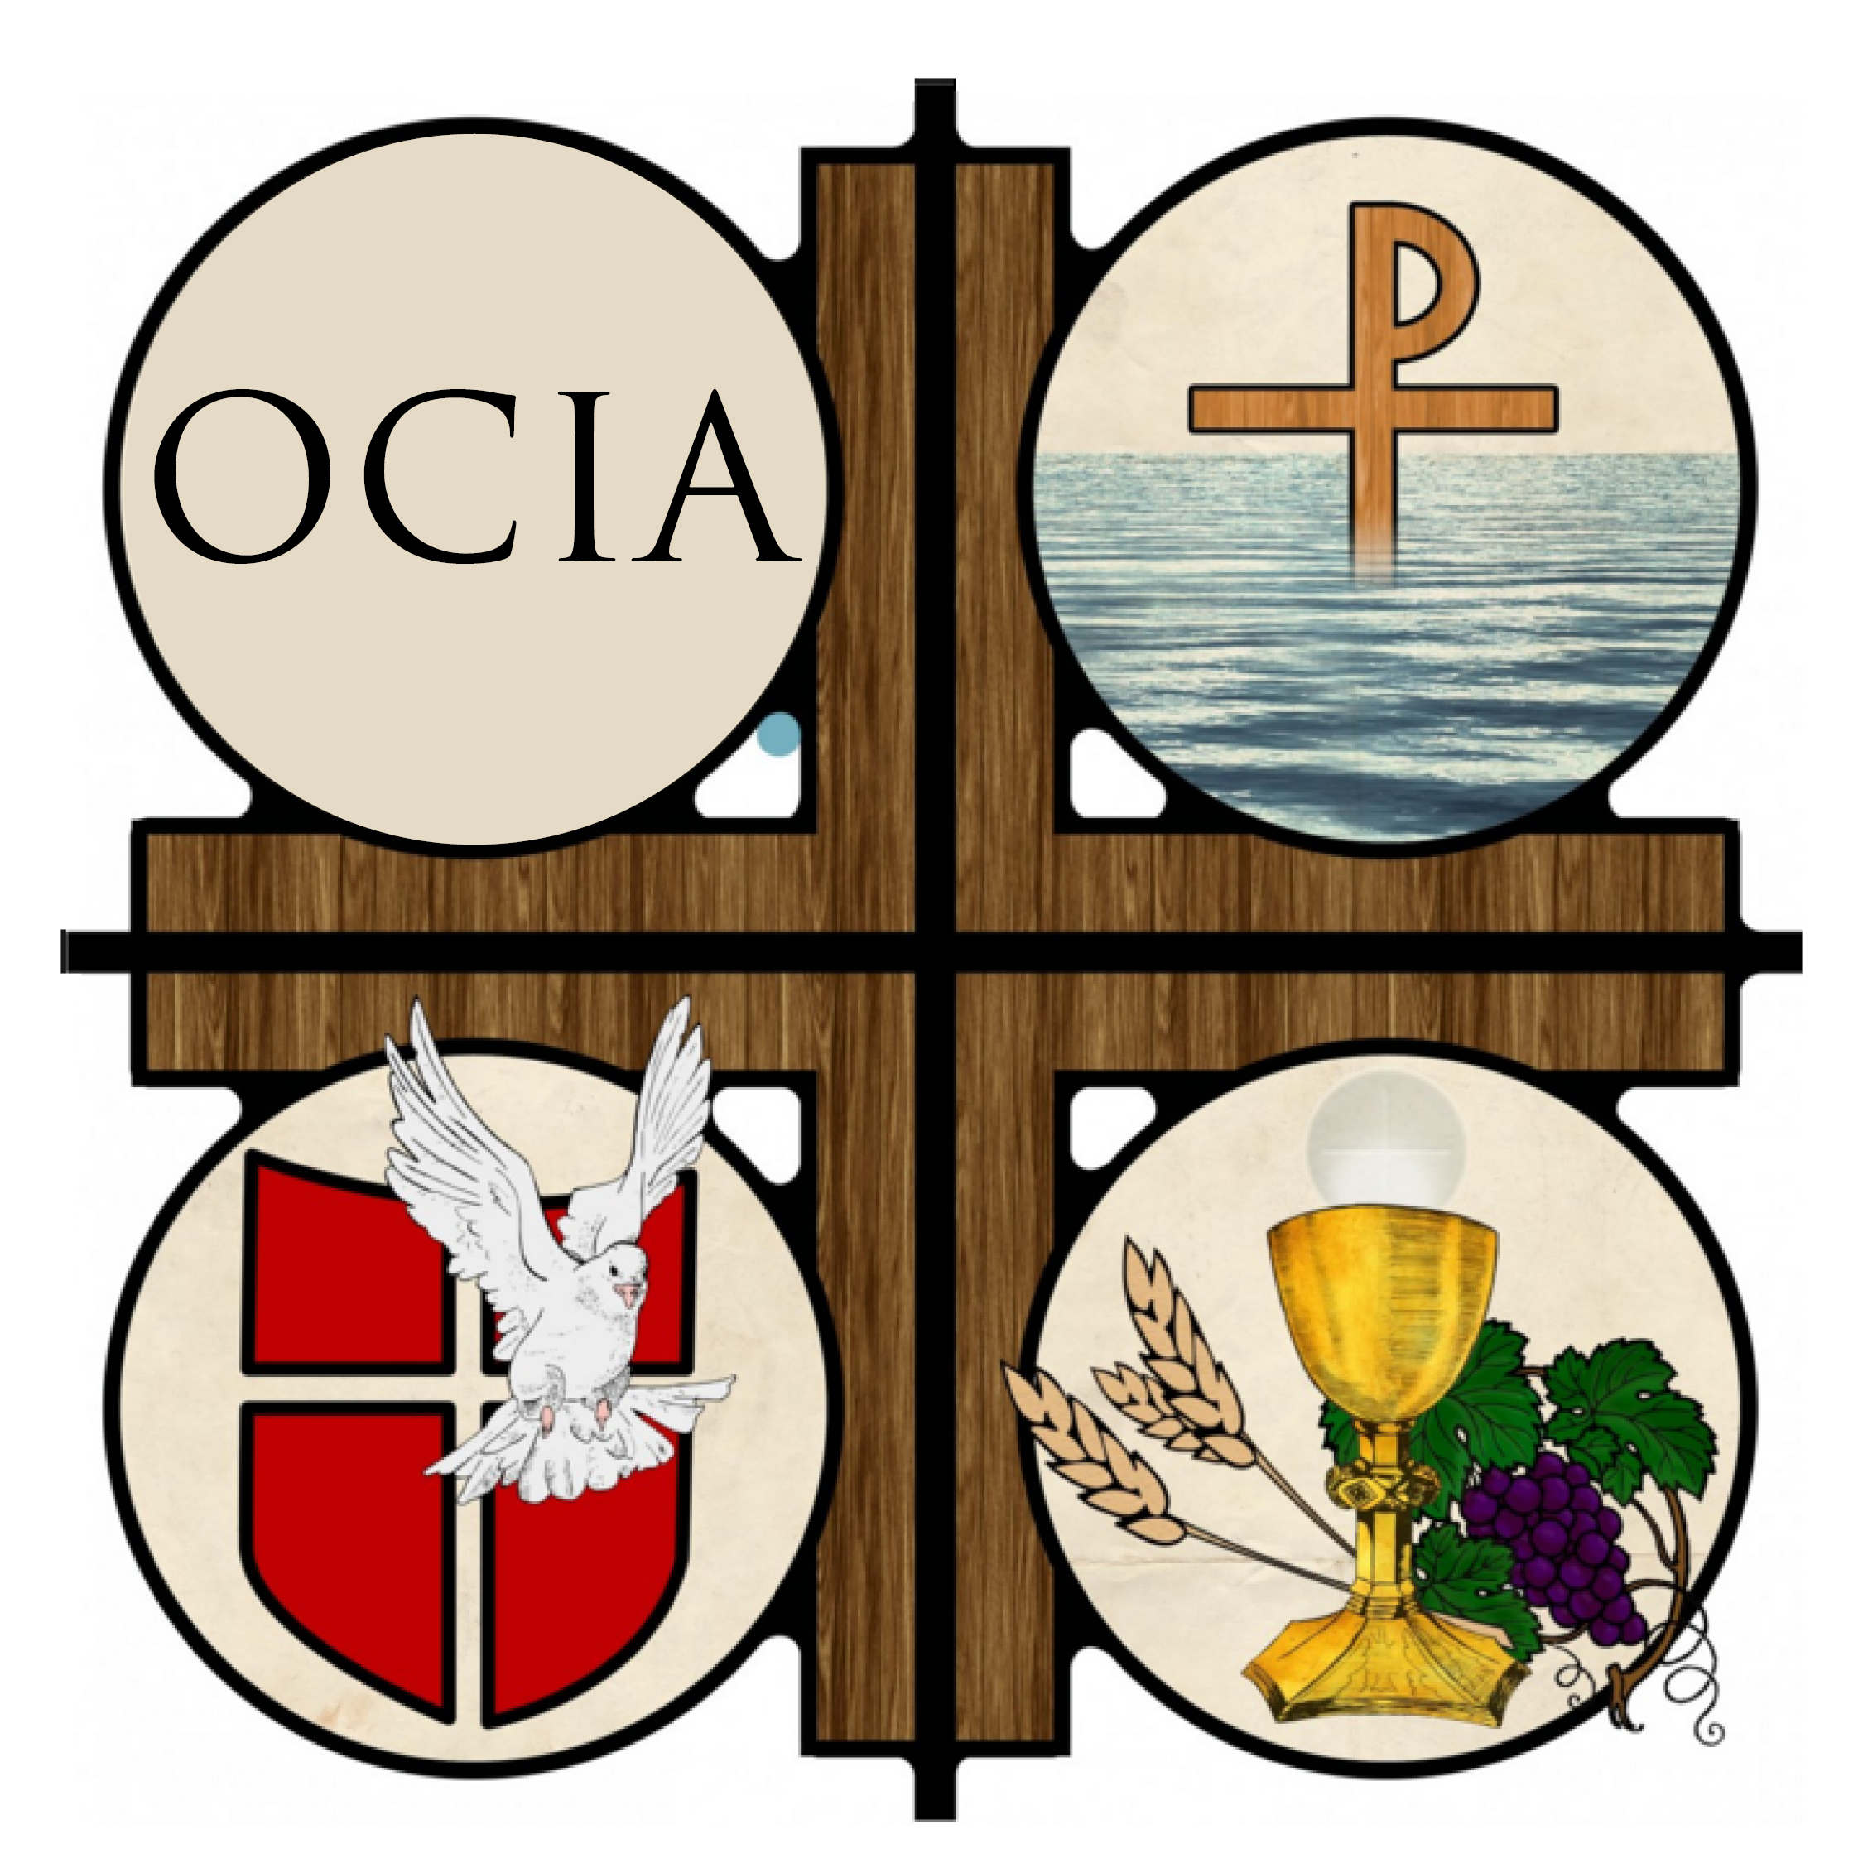
IMMACULATE CONCEPTION/ST. PATRICK PARISH
New Richmond/Erin Prairie

ORDER OF CHRISTIAN INITIATION for ADULTS
SYLLABUS 2024-2025

Sessions: (Sunday afternoons from 1:00 to 3:00 pm)
Place: Corrigan Hall Room 1 (Church Basement)

Class Event Description 7/12/24

Oct 6 Welcoming, Introduction to Sacraments

Oct 12 Confirmation – IC 5:00 pm
Oct 13 No Class Scheduled

Oct 19-20 19th – Fall Festival IC 20th – Fall Festival St. Pat’s
Oct 20 No Class Scheduled

Oct 27 Prayer, Rosary, My Relationship with Jesus

Nov 3 Mary, the Saints, --Church Tour

Nov 10 Scripture and Tradition

Nov 17 Sacraments: Baptism

Nov 24-Dec1 Thanksgiving Week — No Class Scheduled
Dec 4-5 24 hr Adoration - IC

Dec 8 Christmas Fair - IC
Dec 8 Sacraments: Confirmation, Gifts of the Holy Spirit

Dec 15 Sacraments: Eucharist

Dec 22-Dec 29 Christmas Break –No Class Scheduled

Jan 5 Liturgy and the Mass – Part 1

Jan 12 Rite of Welcoming & Acceptance/9:00 AM Mass @IC
Jan 12 Liturgy and the Mass – Part 2

Jan 19 The Ten Commandments

Jan 26 Sacraments: Reconciliation

Feb 2 Sacraments: Anointing of the Sick

Feb 9 Sacraments: Marriage

Feb 16 Sacraments: Holy Orders, Church Organization, & Structure

Feb 23 The Creed

March 2 Church Seasons, Lent, Devotions, Stations of the Cross

March 5 Ash Wednesday

Class Event Description

March 9 Rite of Election—at the Cathedral -Superior

March 16 Transfiguration

March 23 The Samaritan Woman
** –1st Scrutiny celebrated during Mass

March 30 The Man Born Blind
** —2nd Scrutiny celebrated during Mass

April 6 The Tomb—3rd Scrutiny
** —3rd Scrutiny celebrated during Mass

April 13 Palm Sunday—Triduum—Practice/Walk Through for Vigil

April 19 Easter Vigil—Reception of Sacraments

April 20 Easter Sunday

May 4 Mystagogia

