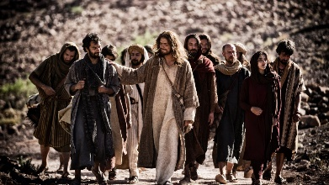
What is an Intentional Discipleship Leader? In short, Pope Francis has called the Church to return to teaching like Christ and his Disciples. At the beginning of Christianity and for the first three hundred years thereafter, Christ and his Disciples taught intentionally, relationally, and apprenticed/mentored others. Immaculate Conception and St. Patrick Parishes are starting the process of returning to this type of Ministry and we began last year with the 6-8 grade students. This year we are moving up to the 9 and 10 graders. Eventually this process will be within all Ministries.

How does this type of catechizing play out in the Confirmation preparation of our young adults?
We will no longer be using the model of table leaders, lectures, and videos. While some of this is necessary for the content piece it is not for the relational and intentional pieces.

- First goal is to build relationships with our young adults we will do this in the following ways:
  - The way we greet the young adults as they enter the room
  - Break down sessions with first conversation/game and then content discussion
  - Gender specific leaders (One male leader for 6 young adult males etc.)
- Second goal is to teach them to pray not praying for them
  - Each time we meet we will begin with prayer
  - As we teach them during the year eventually the prayer time will be created and led by the young adults.
- Third goal is content
  - What does the Catholic Church teach in regards to receiving the Sacrament of Confirmation?
  - We will use Dynamic Catholics Decision Point for the content pieces
- Fourth goal is to help them live their faith
  - Some activities correlating with how Christ and his Disciples lived

Discipleship Groups Process
It is not I who live, but Christ who lives within me. Galatians 2:20
This means that catechesis must often concern itself not only with nourishing and teaching the faith, but also with arousing faith, with the help of grace, opening the heart, converting and preparing total adherence to Jesus Christ. Pope John Paul II

Each D-group session should reflect this call of evangelization of Pope John Paul II. Please follow the process below for each of your meetings with your group.

- Get to know your young adults. It may take a while to build this relationship so be patient and give yourself till Christmas
- Discussion of the video should take place each time you gather. It will be less time at the beginning but focus on spending at least 10 minutes on discussion. Have them write their thoughts on the large pieces of paper provided. These answers are what will be shared with the larger group.
- Bible Versus: Make sure they highlight the bible verse of the night in your session
- Journaling should take place often in your group setting. You may pick one question from the night and have them reflect on it.
- Discuss the previous weeks challenge with them. Ask them how it went? Were they surprised? Hold them accountable to their challenges.
- Return to large group at the given time.

