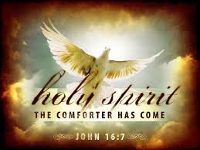
Confirmation Sponsor Check list

It is wonderful that you have answered the call to share your time and spirit with a Confirmation student. This young person has chosen you because they see you as a person of faith who they admire and feel comfortable with. This is a wonderful honor; please trust that God will guide you both on this amazing journey. As a sponsor, you will be asked to fulfill the following:

- Attend the Entrance Ritual at Sunday Mass on November 5, 2017
    - (Select ONE) 9:00AM at Immaculate Conception Church
OR 11:00AM at St. Patrick’s Parish
Meet with your candidate 7 times to complete Sponsor /Canidate discussion Guide
    - Decision point: https://dynamiccatholic.com/confirmation/program-view
    - Fill out Sponsor Letter of Recommendation and Walking the Journey of Faith forms. Return to Kim Palmer by April 25, 2018
Attend the Confirmation Rehearsal and Confirmation Ceremony
- Usually scheduled in October
- The Sacrament is scheduled by the Bishop and we are notified of the
Exact day and time by August.
Pray for and with the candidate
- Attend Mass on a regular basis preferably with Candidate
Share your faith journey and discuss concerns with your candidate

Confirmation Sponsor Letter details are located on the final page of the Discussion packet

