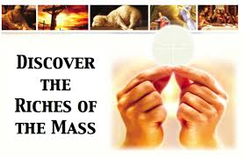

Facilitator: Ragna Raasch
Based on the revised translation of the Mass, this four-part program takes participants on an exciting tour of the Liturgy as it explores the biblical roots of the words and gestures we experience at Mass and explains their profound significance. See, perhaps for the first time, why we say what we say and do what we do every week at Mass. The words and gestures will be seen in a new light, giving new life to the liturgical experience. This is a 4 part series put out by Ascension press.

Dates: October 3, 10, 17, 24, 2017
When: Tuesdays, 6:30 to 8:30p
Where: Ed Center, Multi-purpose room
Facilitator: Ragna Raasch
Cost: $20.00 for workbook
Register by filling out the attached forms.
The Mass
A Biblical Walk Through

Dates: October 3, 10, 17, 24, 2017
Name: _____________________________
Phone #: ____________________________
Cost: $20.00 for workbook
Return this form to the CF Dept. by October 15th or contact Kim Palmer: 715-246-4652, x 228.

