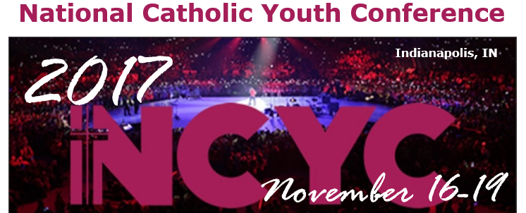
Schedule includes keynote addresses, concurrent and workshop sessions addressing a wide variety of topics as well as opportunities for liturgy, reconciliation, prayer and worship, recreation and special activities such as concerts, exhibits, and the interactive thematic park.
For H.S. students (2017-18). Cost estimate: $550-$600. Fundraising & financial assistance available.
Participant Pre- Registration Form
Name (First, MI, Last):_______________________________ Birthdate: _______________
Sex: M / F T-Shirt Size (Adult Men’s Sizes) S M L XL XXL XXXL
Address: ________________________ City/ST/ZIP: ________________________________
Parish Name: Immaculate Conception/St. Patrick Parish City: New Richmond
Parish Group Leader: Kendra Mitchell (715-246-4652 x247, kendra.mitchell@frontier.com)
Mother/Guardian: ______________________ Father/Guardian: ____________________
Mother’s Cell Phone: ___________________ Father’s Cell Phone: _________________
Home Phone: __________________________ Email: _____________________________
Emergency Contact: _____________________ Relationship: _______________________
EC’s Home Phone: _____________________ EC’s Cell Phone: _____________________
Due with Initial Down Payment of $175 to Parish by February 22nd, 2017.
Please make checks payable to: Immaculate Conception (with NCYC in memo)

